**Real-time Multi-class fish identifier**

**on edge device**

1st Week Report

Member: Trà Đăng Khoa – 17637, Nguyễn Hữu Minh Quang – 17452

* **1st week**:

Finding dataset / testing ML model phase.

* Planning to use and test 2 Machine Learning models: YOLO and FOMO.

**Tra Dang Khoa: testing FOMO model on edge impulse website.**

* I have test trained images of species of a fish named Bangus (milk fish) and the image of myself. The result is F1 24.6 % and accuracy 15.91% which is really bad. Used 221 images.

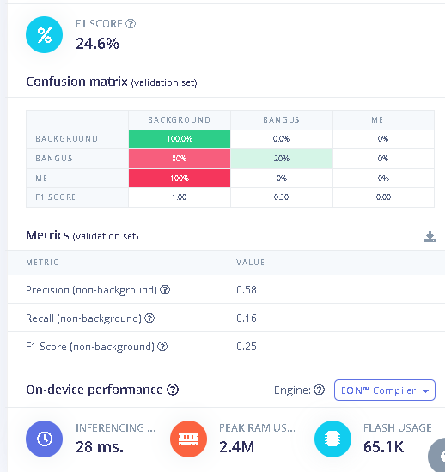

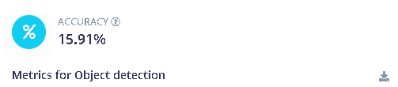

the dataset :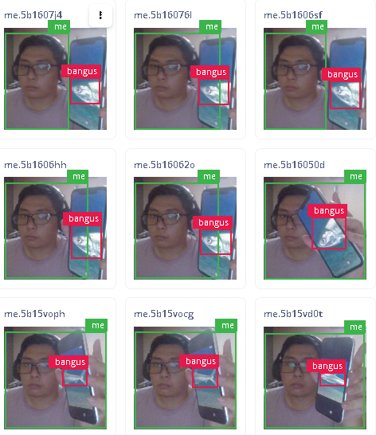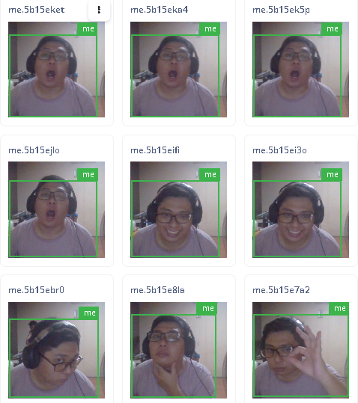

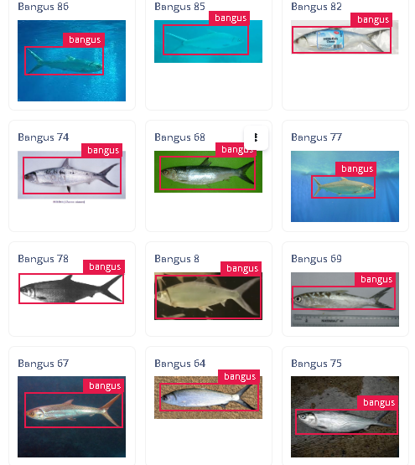

Its true that the dataset is not very good.

and the labelling could use some works.

Thus I plan to get better dataset.

**Problem**: the edge impulse website has a limit which is the computing time can not be exceeded 20 mins. Thus for larger dataset, this is impossible unless you have paid the money.

**so the FOMO model won’t be used. The focus will go to the YOLO model. YOLOv10 to be exact.**

**Nguyễn Hữu Minh Quang’s work : Learn about yolov10n and collecting dataset**

**YOLOv10**

**Introduction**

YOLOv10 represents a significant leap forward in the realm of object detection, pushing the boundaries of speed and accuracy. This cutting-edge model, developed by researchers at Tsinghua University, introduces a holistic design approach that optimizes various components for both efficiency and performance.

In this project, we will use yolov10n, the ‘n’ stands for nano, this version is suitable for small edge device such as raspberry pi that would be used at the end of the project for real-time object detection. Our goal is to detect and classify fishes in real-time through edge device

**Progress**

In this first week, we have done the first step that is compulsory for any AI project, which is collection of data, in this case, fishes’s images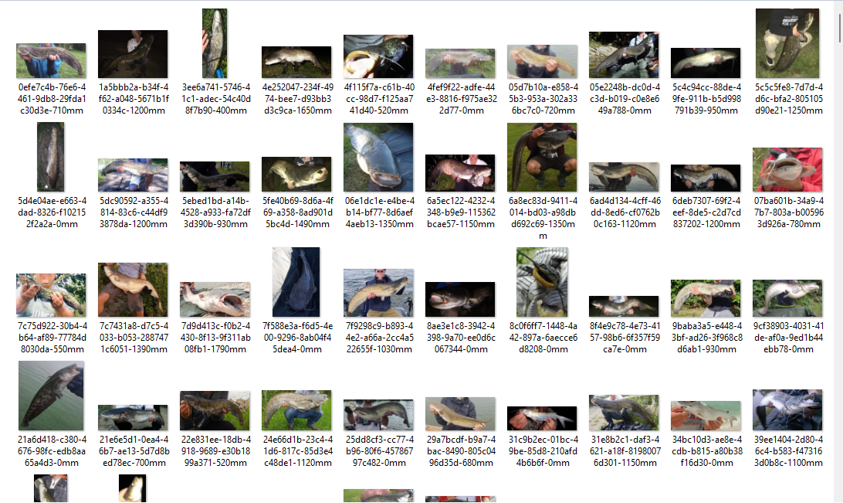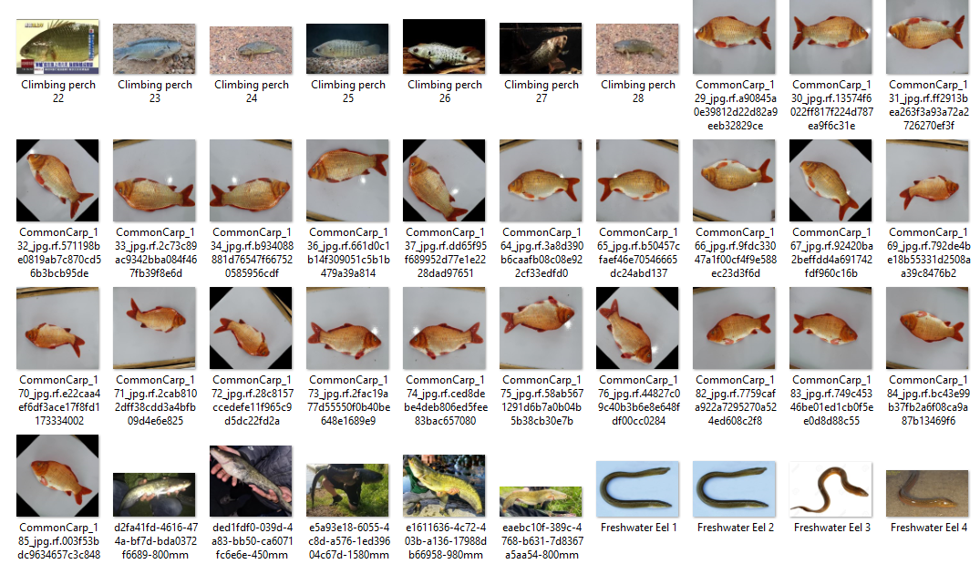

**figure 1 : some images for the dataset**

Our model is planned to be able to detect up to 10 different species living in freshwater. While we have the dataset for the majority of classes, there’s still a few species that come with a lack of online images for the dataset, which will require us to take real-life pictures manually.

In this week (second week), we will try to collect all the remaining dataset and resize them to 640x***, the resolution that is suitable for YOLO, rename them with ascending numbers (1,2,3…). After that, we will upload the images on the website makesense.ai for annotation and will start to train them on google colab later.

**2nd week:**

We focus on gathering dataset.

We have gathered 875 images. Mr Quang was the main gatherer for these images

During the gathering process. we found two species that are hard to find the dataset for thus removing them. So now we have only 8 species.

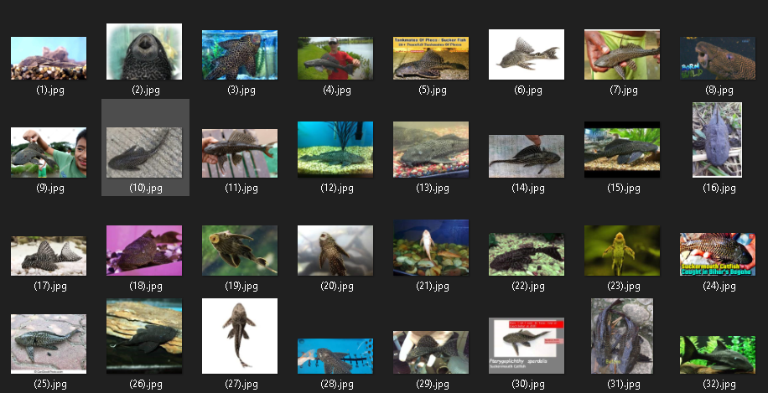

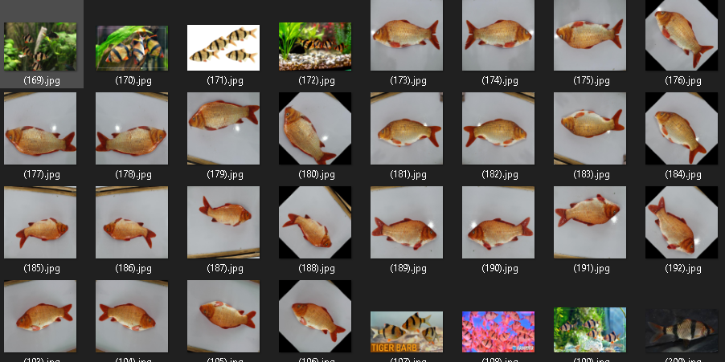

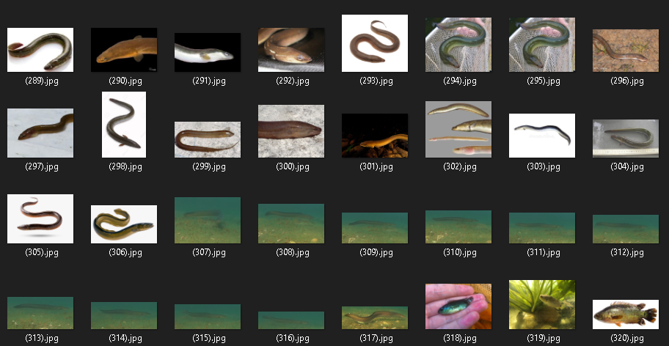

Formatting images to a more consistent format like “.jpg” and with ascending numbers like 1, 2, 3,... I also helped label 432 images using makesense.ai. The remaining will be done by mr. Quang.

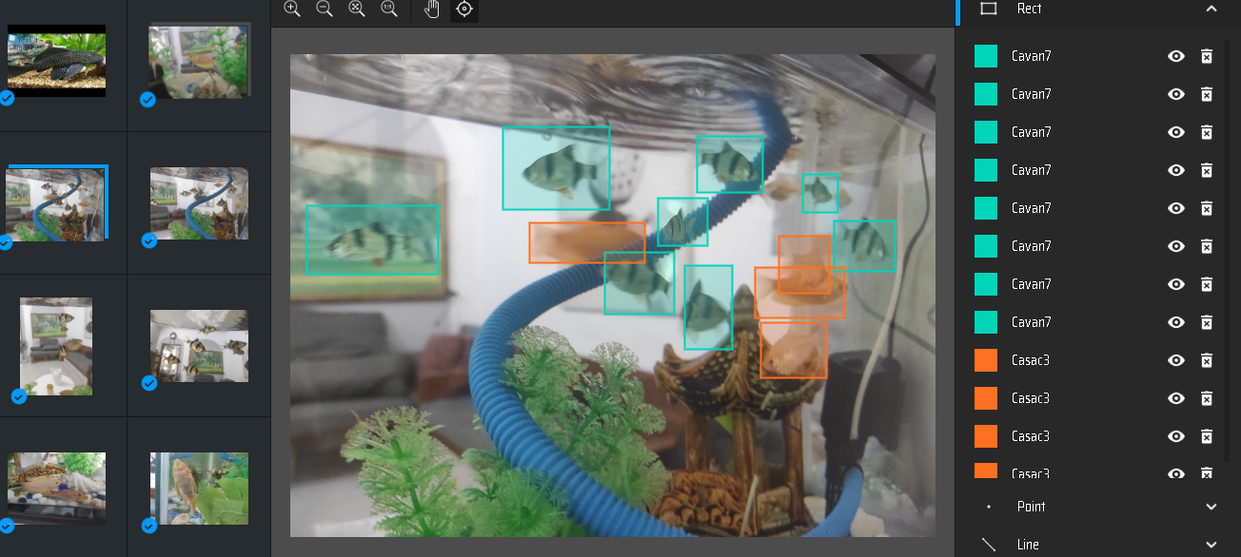

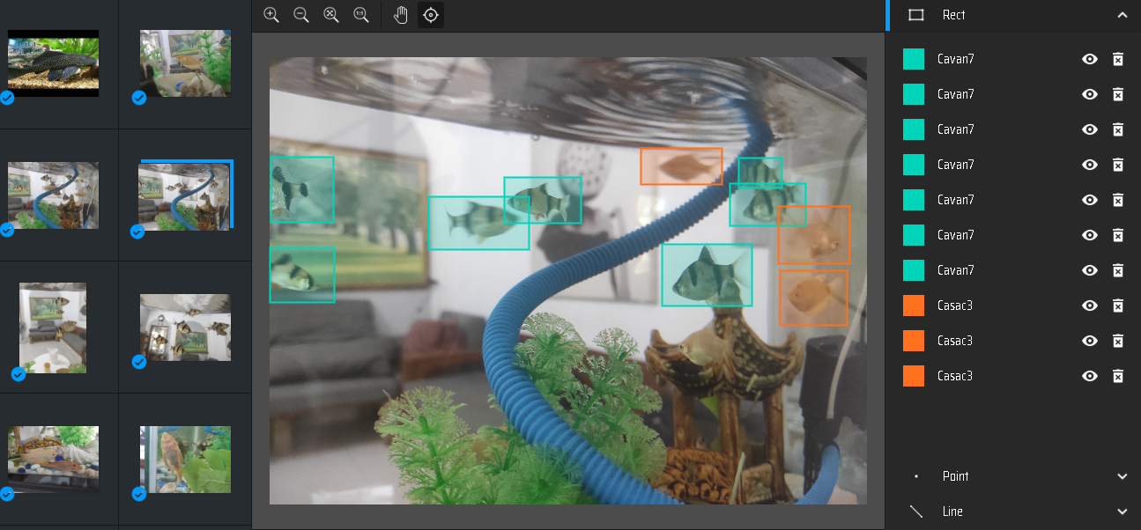

additionally (Tra Dang Khoa) i also help resize 875 images to 640x*** for ,hopefully, better accuracy when training the YOLOv10n model.

Since we gather most of the datasets by ourselves instead of using the dataset online, the progress was slow. That is why we haven’t tested training the model yet. Which is why we plan to test training YOLOv10 nano next week and learn how to deploy the model on target devices (raspberry pi 4 or 5)

**3rd week:**

Deployment: after researching, we found that a raspberry pi 4 or 5 camera doesn’t suit an arduino uno microcontroller, because its resource need is more than the amount of arduino uno is allowed. We could use a Raspberry pi board but since arduino uno is available for us to test, we will use it instead. Using platform IO extension on Visual studio code.

here is the pipeline that i proposed: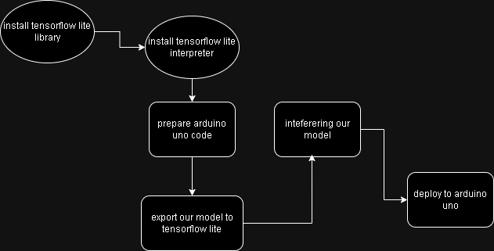

I also set up some code to train another YOLOv10 on google colab incase mr Quang got errors in his model. I used roboflow to help set the dataset from the images we gathered

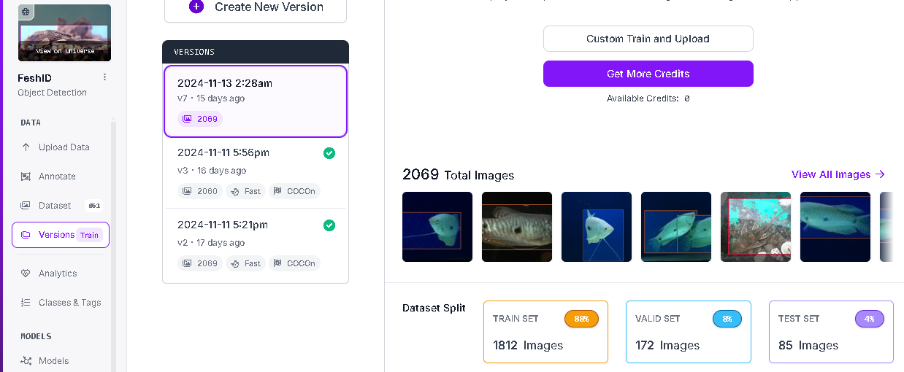

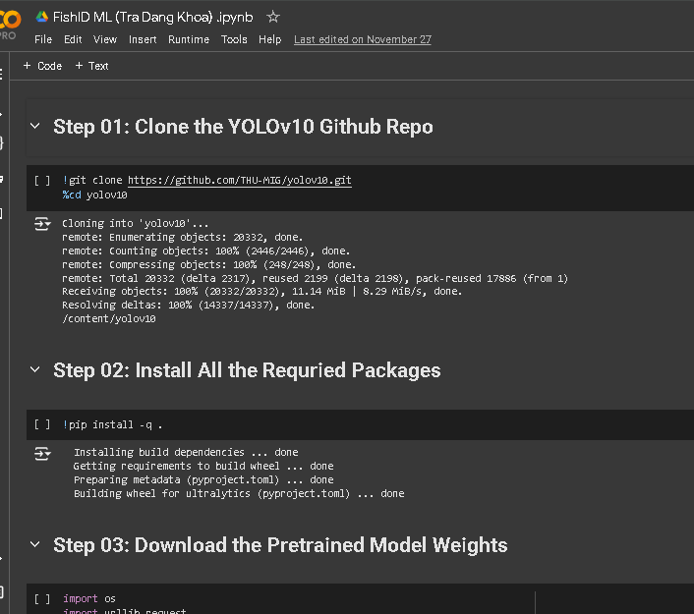

this is only the backup if there something go wrong with Quang’s training code

**Train the model : Nguyen Huu Minh Quang**

**Model** : While Khoa digged into how to deploy the model, my mission is to train the model with the dataset that we have prepared in the second week

In order to train data on yolov10n, we divide into two catalysts that required :

* Coco128 folder : contains images and their labels
* coco128.yaml : contain the instruction to the coco128 folder and the id of each class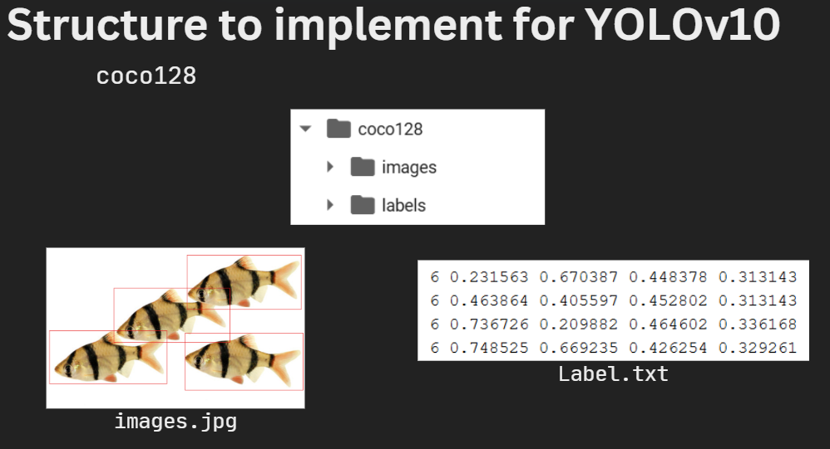

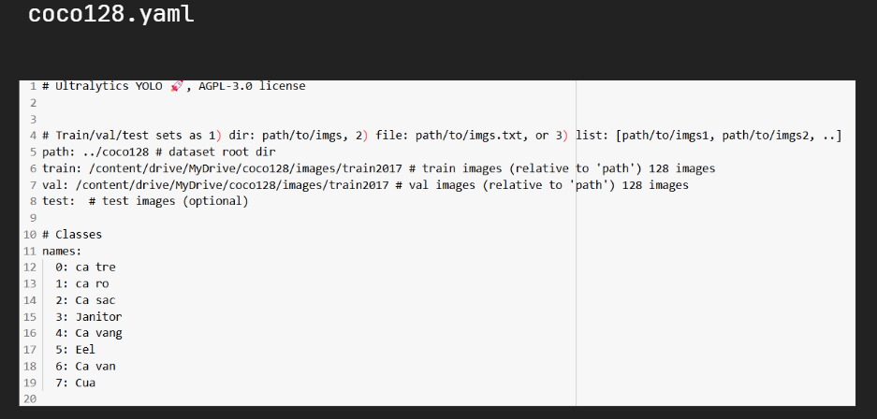

**figure coco128 folder** **figure coco128.yaml**

**Train model :   
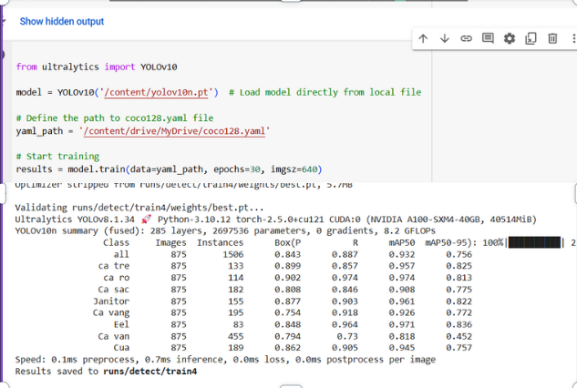**

After training,overall, the recall and precision parameters are high, indicating that it is good at finding most of the objects of interest and the model predicts something as positive, it's likely to be correct, but it might miss some true positives.

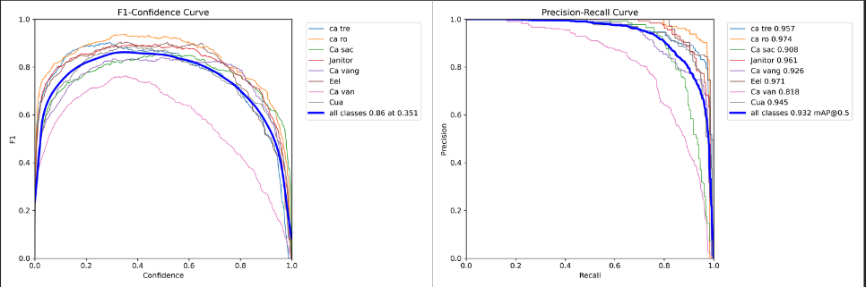  
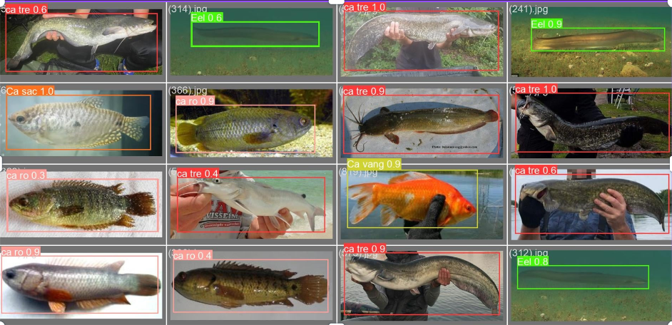

However, there are still issues to be addressed when it comes to video and real-time detecting. The model is still confused when fishes accelerate or turn around all in a sudden, this will be the object that we will try to resolve in the following days.

**Week 4:**

**Testing deployment: (Tra Dang Khoa)**

Successfully converted our model to int8 tensorflow lite format for reducing the size of our model. After conversion, the model current size is 2mb.

Before setting up Arduino Uno code, our model needed to convert to C array format for the machine to read the model. We using xxd to help the conversion to best.h (“best” is the name of our model)

I installed necessary library such as micro tensorflow lite and ArduinoSTL

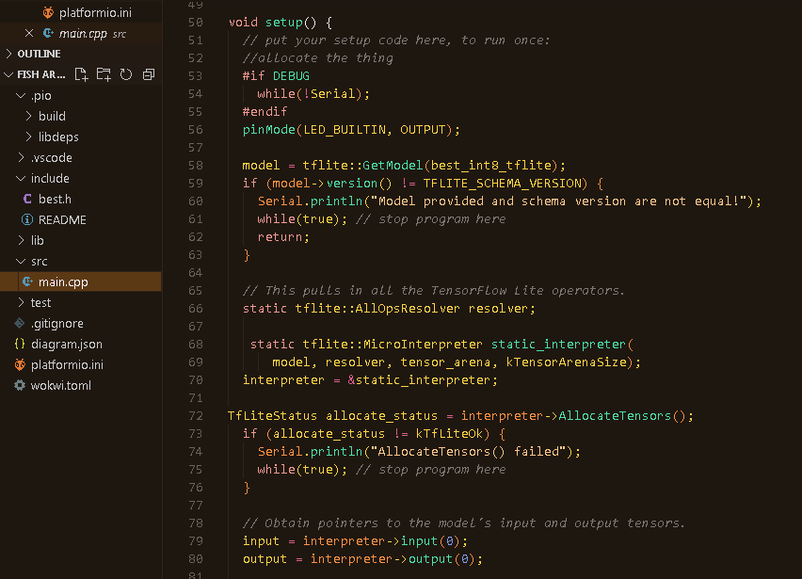

Finished Arduino Uno code setup but we ran into obscure errors. One is from our C array model, and it seems the error relates to C++ array size problems. Two are Arduino uno library errors. Unfortunately, we haven't been able to fix the problems combined with the compatibility issues with the tensorflow lite library which only supports arduino nano.

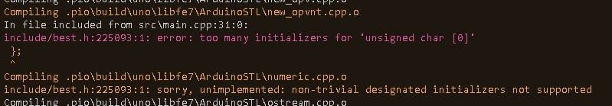

.error 1

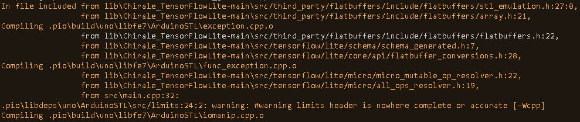

.error 2

Additionally, the Arduino Uno microcontroller is very resource constrained. We thought when we convert our model to tensorflow lite to help it run on edge devices. But its size is more than what Arduino uno can handle, which is 32kb.

Thus, we want to switch to a raspberry pi microcontroller for hopefully smoother deployment.

**Additional data gathering for model improving : Nguyen Huu Minh Quang**

This week, a data collection process was undertaken to improve the performance of a fish detection model.

Problems of the model

* Lose track of objects
* Objects behind other objects
* Objects from different angles
* Texture of the environment

**Data collection strategy :**

Identifying Challenging Scenarios:

* **Sudden Turns:** Captured images and frames where fish exhibit rapid changes in direction. This includes sharp turns, sudden stops, and rapid accelerations.
* **Occlusions:** Collected images and frames where fish are partially or fully obscured by other fish or objects in the environment. This includes instances of fish swimming behind one another or being partially covered by plants or debris.

Data Acquisition Methods:

* **Direct Image Capture:** Used a high-resolution camera to capture still images of fish in various poses and orientations, focusing on moments of sudden movement and occlusion.
* **Video Frame Extraction:** Extracted individual frames from recorded videos of fish tanks and natural aquatic environments. This allowed for precise selection of frames that captured the desired scenarios.

Expected Impact on Model Performance

By incorporating this diverse dataset into the model training process, we anticipate the following improvements:

* **Enhanced Detection Accuracy:** The model will be better to detect fish in complex scenarios, such as those involving rapid movement and partial occlusion.
* **Improved Localization Precision:** The model will more accurately localize fish, especially in crowded or cluttered environments.
* **Robustness to Varying Conditions:** The model will exhibit increased robustness to changes in lighting conditions, water clarity, and fish behavior.

**Week 5:**

**Testing deployment part 2: searching for hardware (Tra Dang Khoa)**

For the last week, the deployment for arduino uno was not successful because of the reasons we mentioned above. Thus I spent a week researching raspberry pi 5.

What I got is the raspberry 5 acts as a micro computer with its own OS called Raspberry pi. You can run it as a computer and simply run the AI on it. So our team decided to buy it for easier deploying. But when I looked at the board’s price on its website, it was very overpriced. After searching I found a website that is at least much cheaper than any other alternatives which is hshop.com. This what i have gathered:

Microcontroller:

1. Raspberry Pi 5 Power Supply PD 5.1VDC 5A 27W USB-C (285K)

<https://hshop.vn/nguon-chinh-hang-official-raspberry-pi-5-power-supply-5vdc-5a-27w-usb-c>

2. Raspberry Pi 5 Aluminium Heatsink & PWM Fan (125k)

<https://hshop.vn/tan-nhiet-raspberry-pi-5-heatsink-pwm-fan>

3. (~195k) sd memory card SanDisk MicroSDXC Class 10 UHS-I 100MB/s 64GB

<https://hshop.vn/the-nho-sandisk-microsdxc-class-10-uhs-i-100mb-s-64gb>

4. Raspberry Pi 5 RAM 4GB (2.090.000 )

<https://hshop.vn/may-tinh-raspberry-pi-5-ram-4gb>

Camera:

1. Raspberry Pi Camera Module V2 IMX219 8MP (680k)

<https://hshop.vn/camera-raspberry-pi-v2-8mp>

2. FPC camera Raspberry Pi cable – length 15cm (cần để nối vô raspberry pi 5, 25k)

<https://hshop.vn/cap-chuyen-csi-fpc-15-pin-1-0mm-to-22-pin-0-5mm-for-raspberry-pi-jetson-nano>

Total cost: 3.400.000

I did try to not go over our budget constraint but it's still quite expensive. For an SD memory card we can go find the cheaper one that doesn’t affect the performance of the microcontroller. For the camera, I tried to balance the quality and cost. That is the reason why I chose the Raspberry Pi camera v2 IMX219 because it has 8 megapixel and supports up to 1080 HD resolution, while the price is still expensive but affordable. Additionally it is supported by raspberry pi so the compatibility is good. It also has community support and tutorials which can help to smooth the deployment process.

**Train the model with additional data gathering last week : Nguyen Huu Minh Quang**

The model now have been trained by addition data collected last week

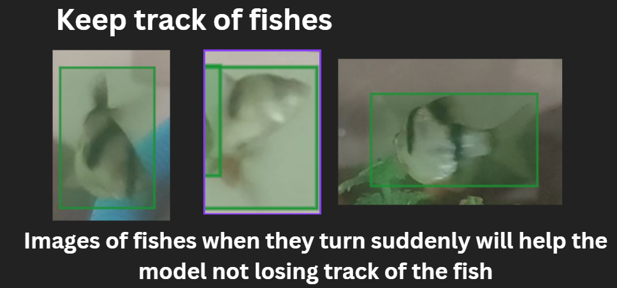

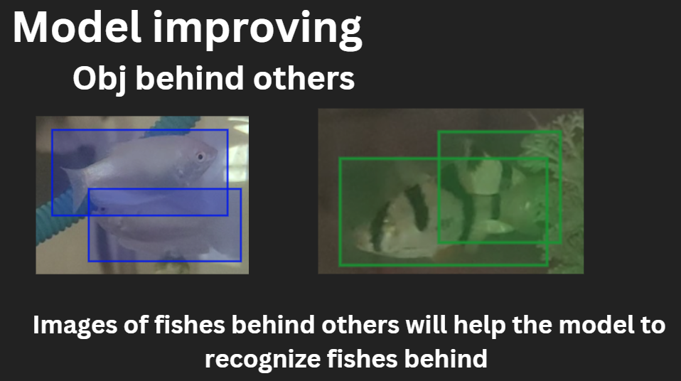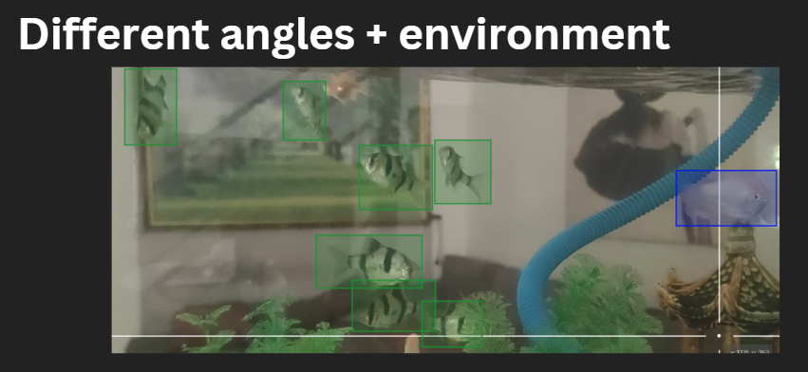

The model is now better to detect fishes in complicated scenarios such as those involving rapid movement and partial occlusion, in addition, accurately localize fish, especially in crowded or cluttered environments.

Finally, the variety of the surrounding environment also help the model to be robustness, such as lighting condition, water clarity and decoration inside the tank

**Week 6:**

**Model deployment testing: Tra Dang Khoa**

Since the teacher has covered the hardware, I simply jump to deploying our model on another device that I have , which is my laptop, for testing the model deployment.

The model has successfully deployed on my laptop camera. Although it’s not very good because it detected me as a janitor fish for some reasons.

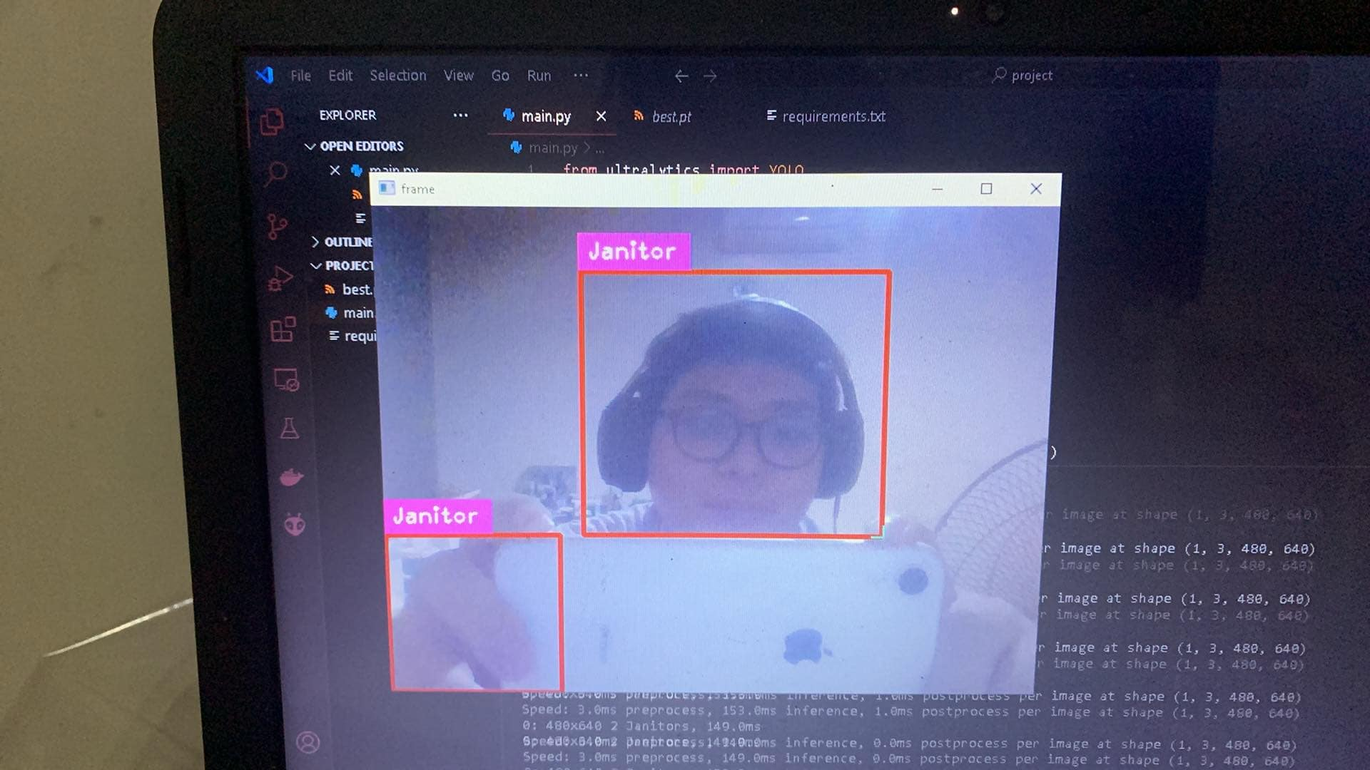

me as a janitor :).

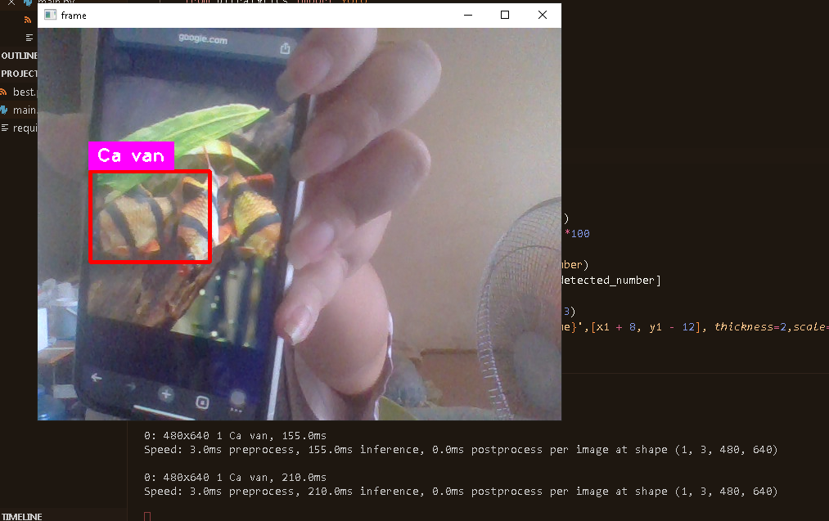

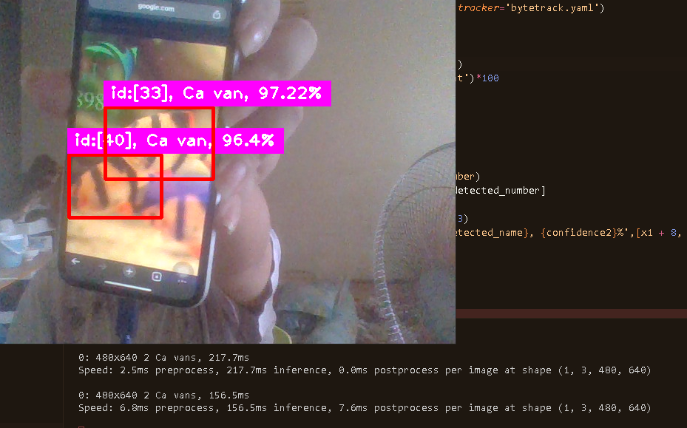

This is the code for the interference. It was not too hard to set up.

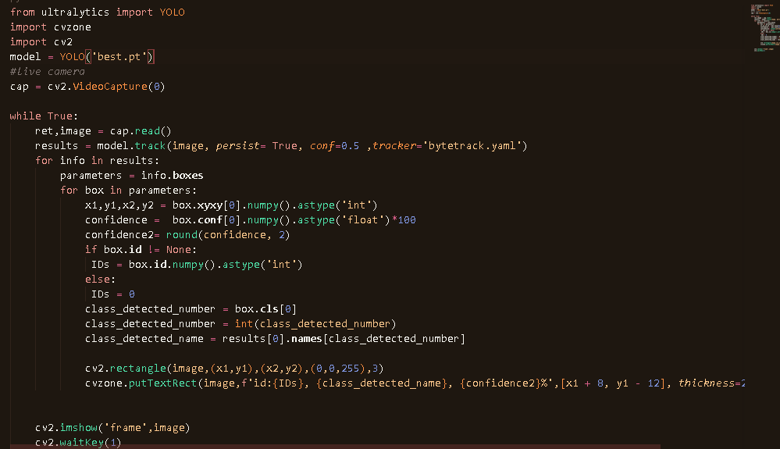

About the performance, I used the old model of our team. The result is not very good. This could be because of my laptop's quality. But we want our model to perform well even in a non-clear environment for practical purposes .Thus we plan to reform our dataset and train a new model for better performance.

**Model and data problem : Nguyen Huu Minh Quang**

There is a problem with using dataset online, images contain noise, watermarks, or other artifacts that negatively impact model training. The model gets extremely confused when being tested in our water tank environment

After discussion with professor Hien, we decided to use the data completely being collected in the real world by ourselves instead of using images online for model training, therefore reduce the number of classes to only 6 species : cá vằn, cá sặc cảnh, bình tích, cá buồm đỏ, cá lau kiến, cá neon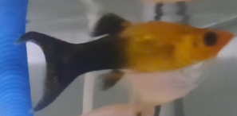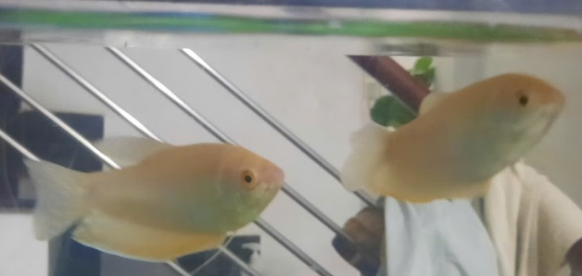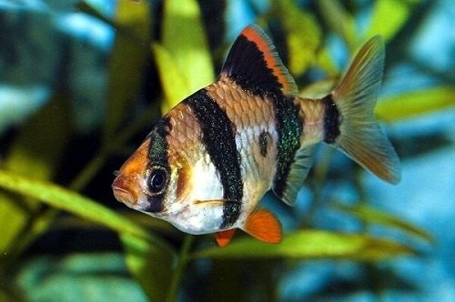

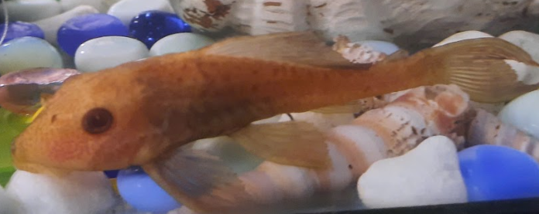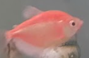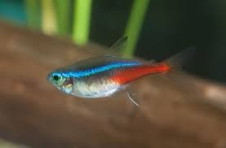

My mission this week was to buy and take picture of out aquarium fishes for our new dataset

**Week 7:**

New model: we still use YOLO nano because of ease of access while providing a powerful object detection ability.

**(Tra Dang Khoa)** help Mr.Quang labeling all new datasets: 102 images. Used makesenseai website

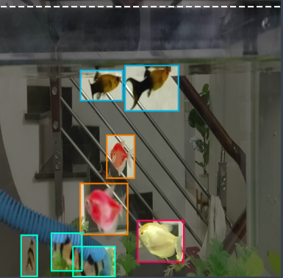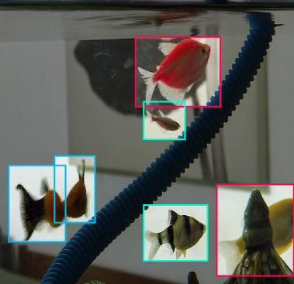

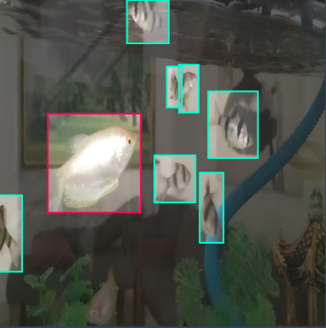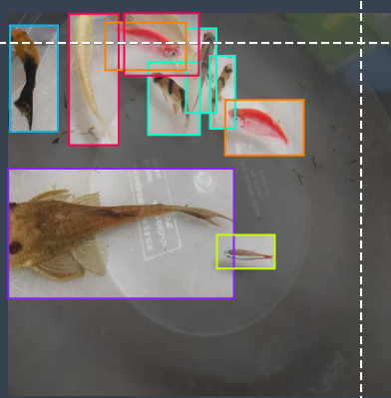

i also use augmentation to increase the dataset variety but when i train my own YOLO model

the result is less effective than Mr quang model that is trained non augmented images

I used 250 epochs and batch size 8. I got **mAP50: 0.74**

Here is the link to the demo: [Tra Khoa Model result demo.mp4](https://drive.google.com/file/d/144C5uOsJm9SqmakGL1uBKhIlQX2dsSp8/view?usp=sharing)

Here Mr quang model :[Quang model result demo.mp4](https://drive.google.com/file/d/1PEE1amTmscRcg2dwTyGoMBRYyTu3bU8j/view?usp=sharing)

all the predictions have a confidence threshold 0.5.

Mr quang model has much better performance than the model on the 3rd week. However it still lose track of the target easily and the average confidence is still too low

**Model training and improving : Minh Quang**

This week beginning the process of training the model

We use in total of 103 images taken from my aquarium tank, below are a few of them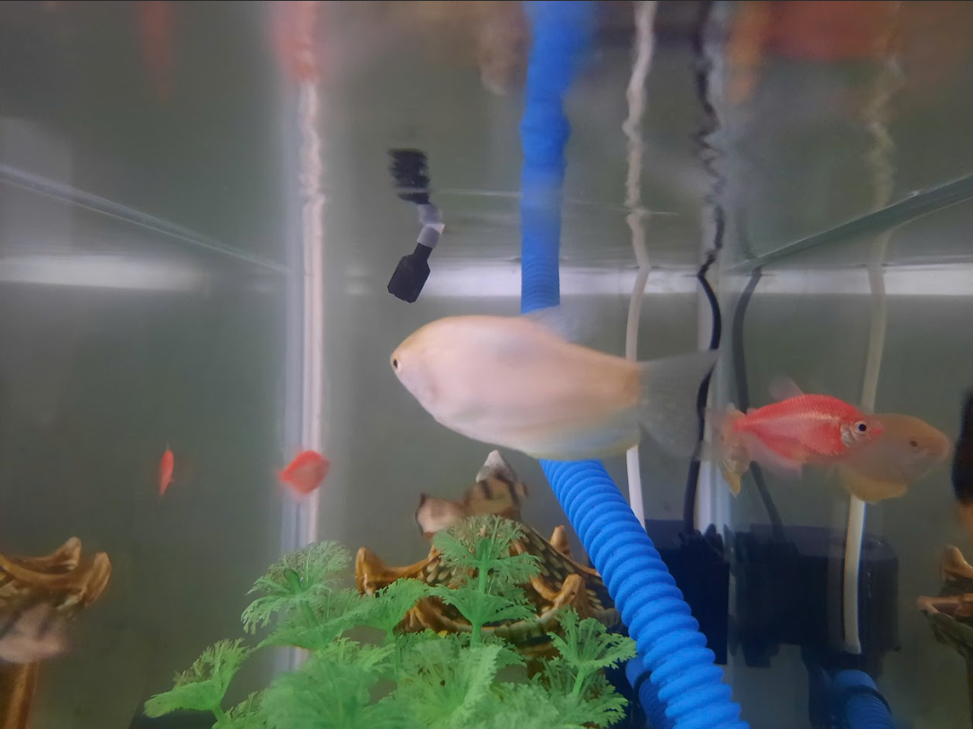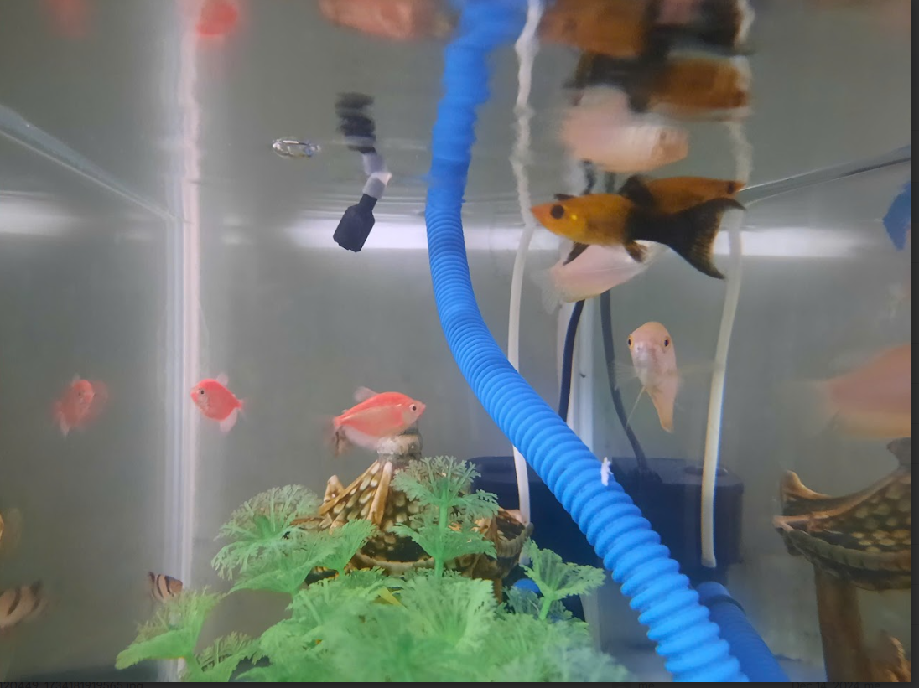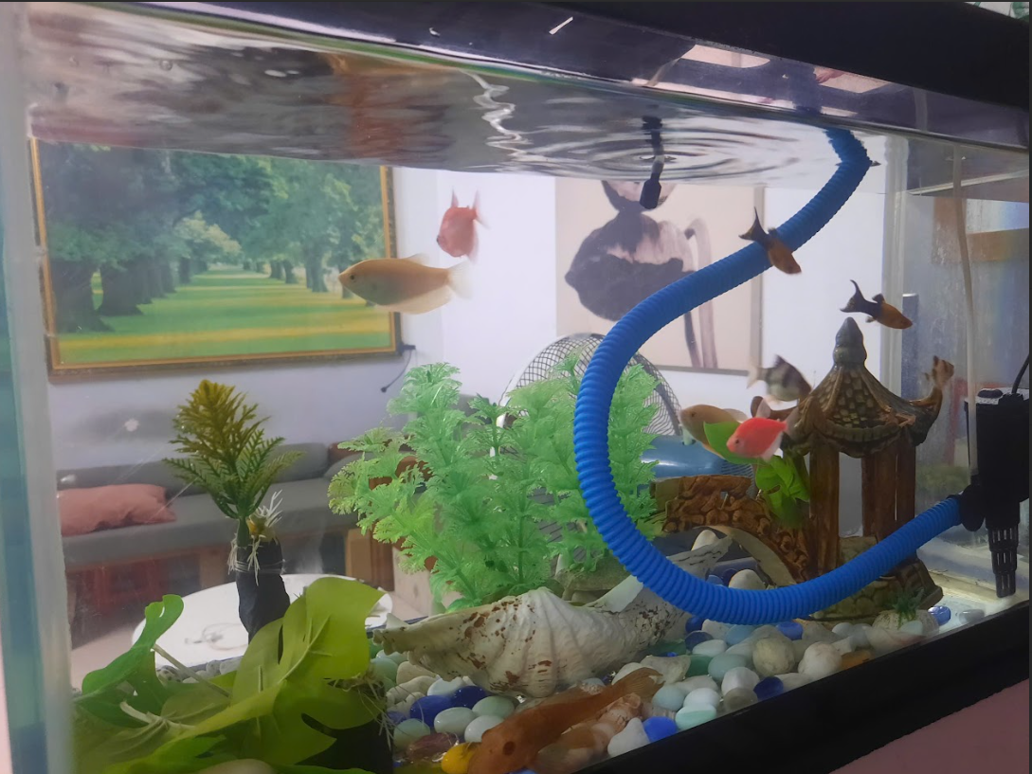

After send the dataset to my partner Khoa for labeling, I retrained our model with our new dataset and here are some result after training with epoch 170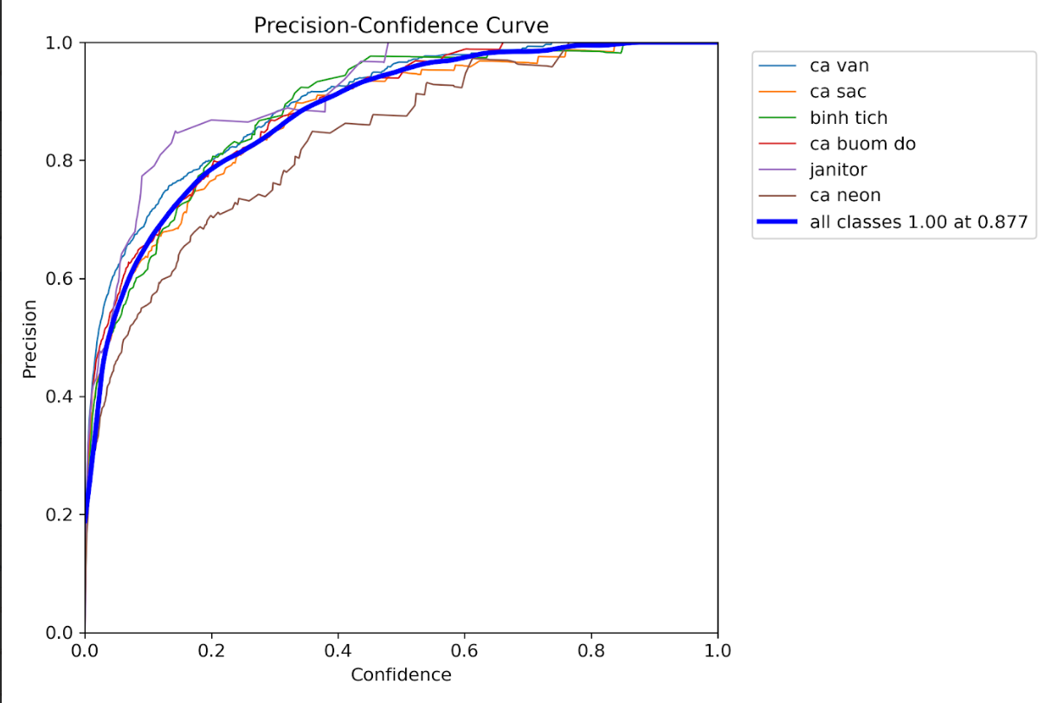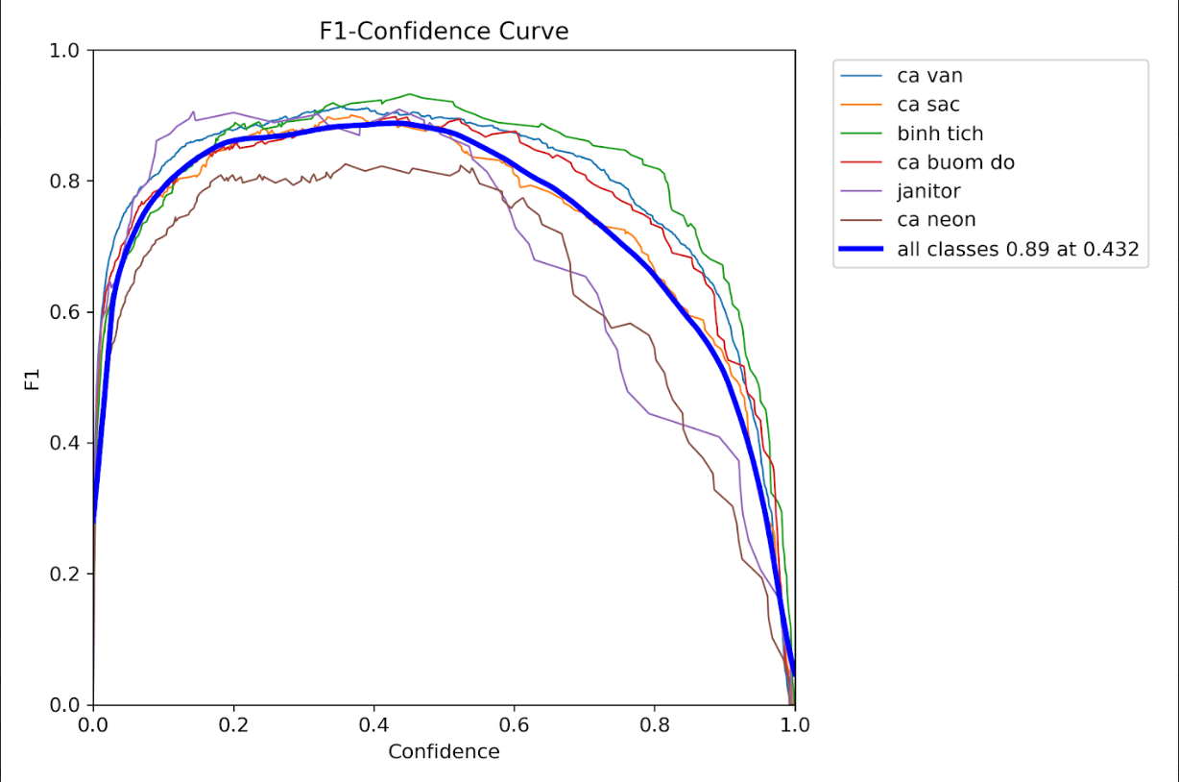

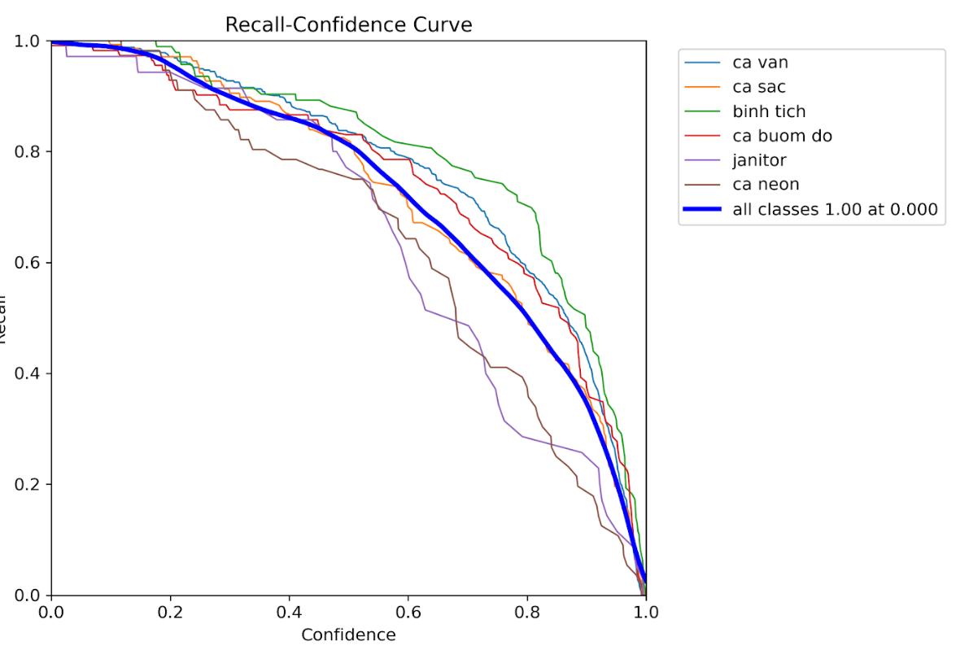

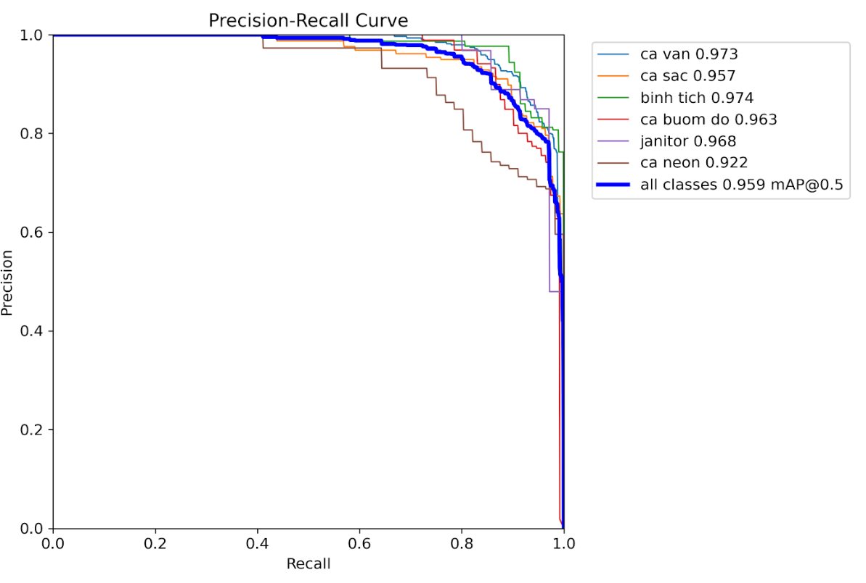

The above charts show that confidence, precision and recall are good in general. However, there is always room for improvement as we want the confidence curve to be closer to 1.0

And here is a link to a demo test on our video : [Quang model result demo.mp4](https://drive.google.com/file/d/1PEE1amTmscRcg2dwTyGoMBRYyTu3bU8j/view?usp=sharing)

Overall, the new improved model is better than the previous model when it is less confused with the environment surrounding it. Additionally, it keeps track of the fishes quite well, however, there are still flaws ,such as a few species still not being highly recognizable by the model as you can see in the video. We plan to solve this by continuing to improve our model by more images of those fish species.

**Week 8:**

**Model Finalizing and improving : Minh Quang**

Overall work of mine this week

* Take more picture for dataset in order to improve the model
* Continue to train the model with extra dataset for improvement in general
* Canon this model as final for deploying on edge device

This week, more pictures of fish which lacked recognition have been taken for model improvement.

I continue to train the model with the new updated dataset , with 80 more additional epochs.

Below are the results of the last week model and newest model

Last week model Newest model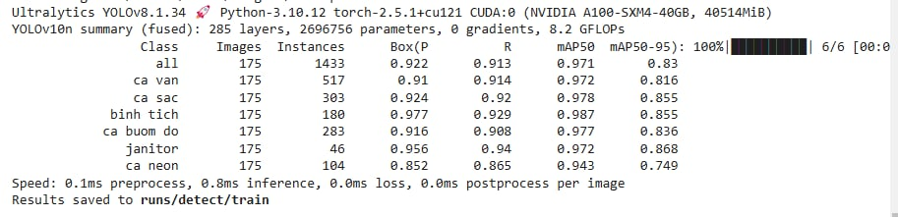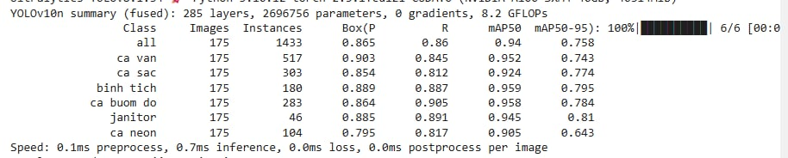

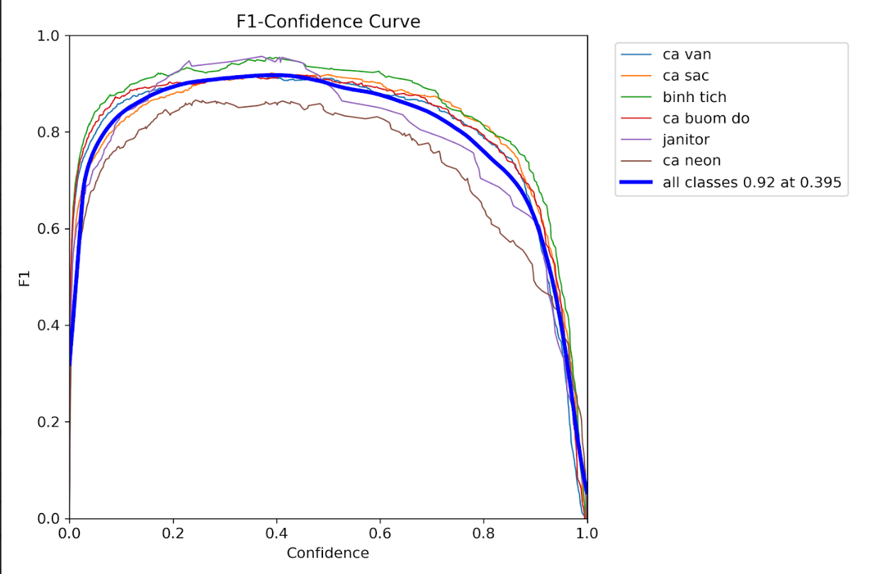

Overall, the model has been improved as you can see in the two same frames cutting from two models testing on the same video as you can see below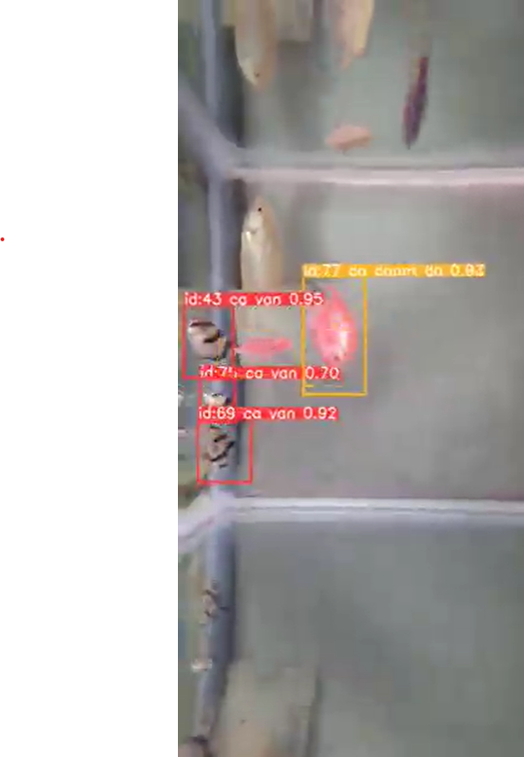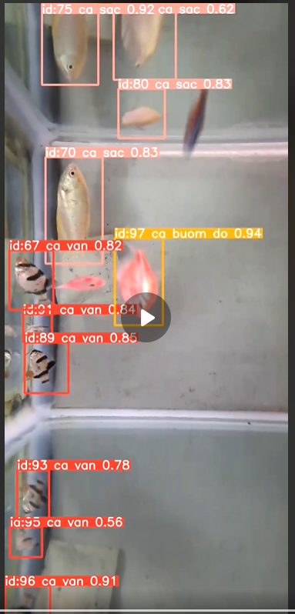

The two are the same frame, but as you can clearly see the difference between the two when the one on the right recognizes more fishes than the left, which proves that the model has been improved significantly.

Eventually, we have decided this model will be our final version to be deployed on an edge device and displayed for the final project presentation.  
  
**Tra Dang Khoa’s contribution:**

Although we have done with the model, I am still not satisfied with the performance. Even with getting less desirable results from training with augmented images last week, I still believe that augmentation can help a lot, so I was trying to find a different library to do the augmentation.

I used an augmentor library to augment our dataset for better ML performance and larger dataset size. There are 8 augmentations that I used:

* Flip (horizontal/vertical) - use this to make model better at detecting different angle
* shear - the same as above
* Rotation - make model more resilient for camera and subjects change
* random crop - better equip model for close up shot
* random erasing - help model to detect the subject that have been obscured by other subject
* random brightness and contrast - help the model less sensitive to light changes
* zoom - make model less sensitive to zooming

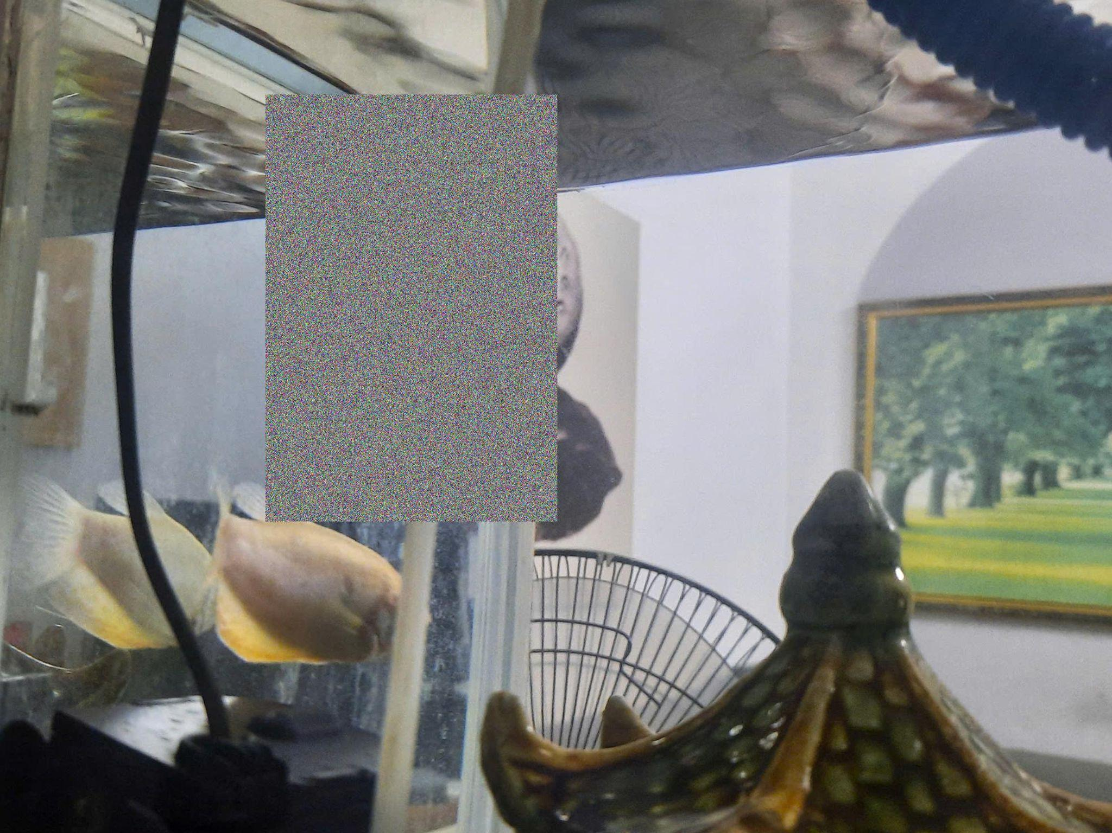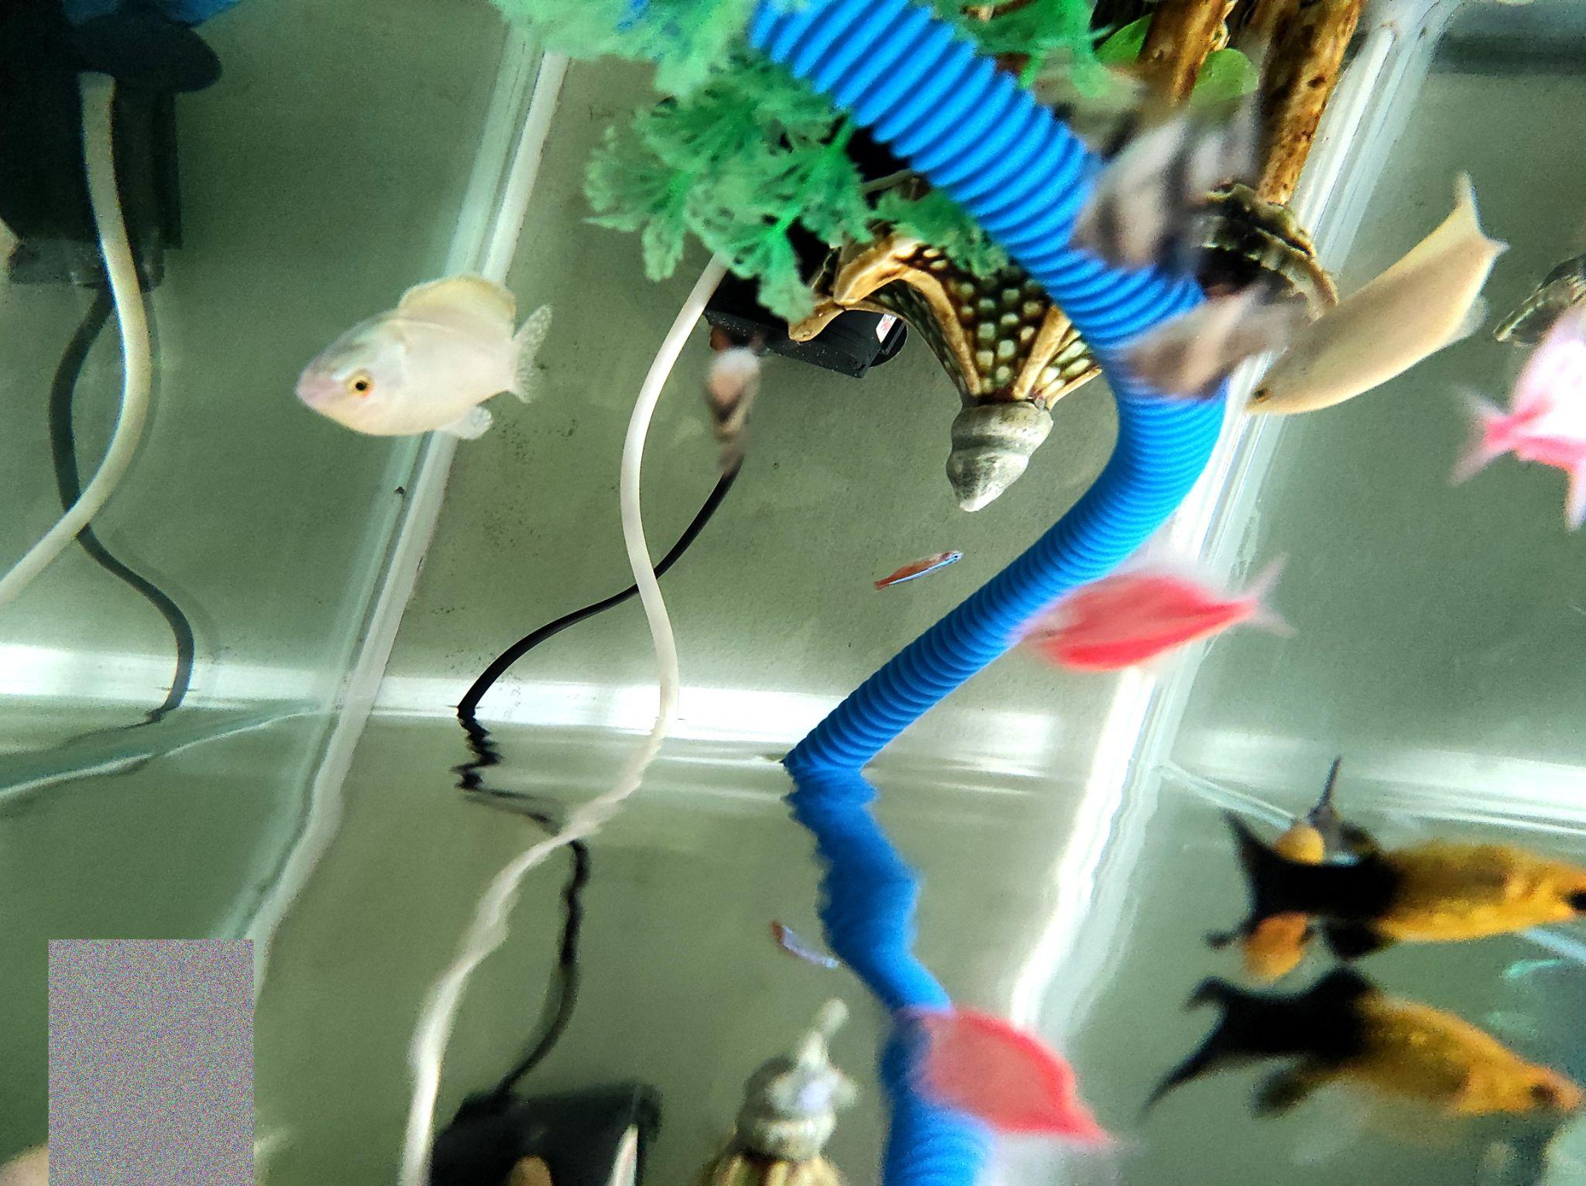

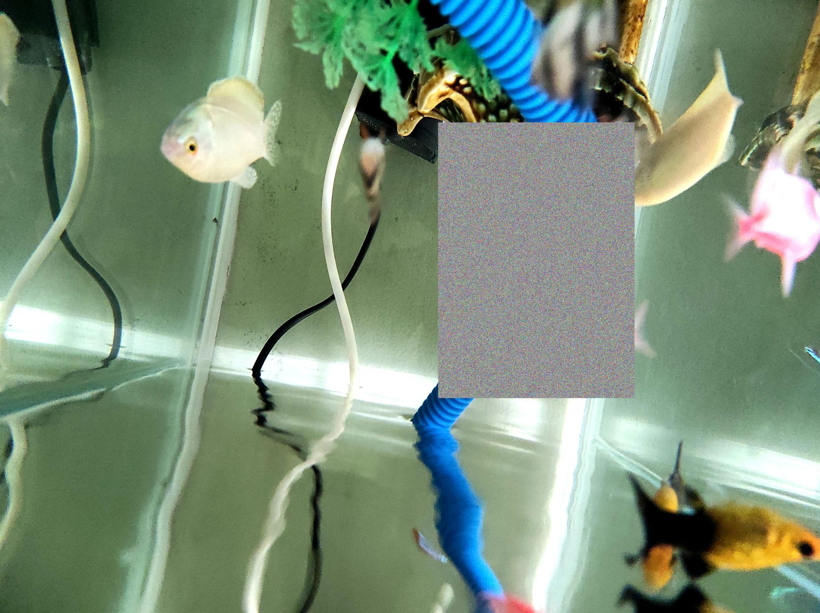

erasing examples.

I sampled 500 augmented images, thus increasing the datasize. We could sample more than 500 images. However, the drawback of this library is that they don’t transform the label so I have to manually label 500 images myself with each image having 3-7 fishes. That's why I chose 500.

here is the code:

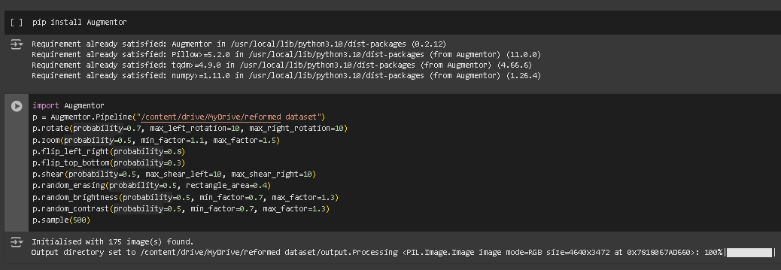

then I also used the roboflow’s augmentation (exposure, saturation) for further increase the size of the dataset to 1 thousand images

Although the labeling process is tedious. The model that I trained using this dataset performed better than Mr Quang’s. making the progress worth it.

here is the demo:

[Khoa's model trained on augmented images.mp4](https://drive.google.com/file/d/1u7NsUQ0ngOwA_TrnSpgtfzc6MBgGkH51/view?usp=sharing)

The model tracking and detecting capability is much better than the previous model. even though we got overall mAP50 0.87 with 0.86 which is lower than Mr Quang’s model 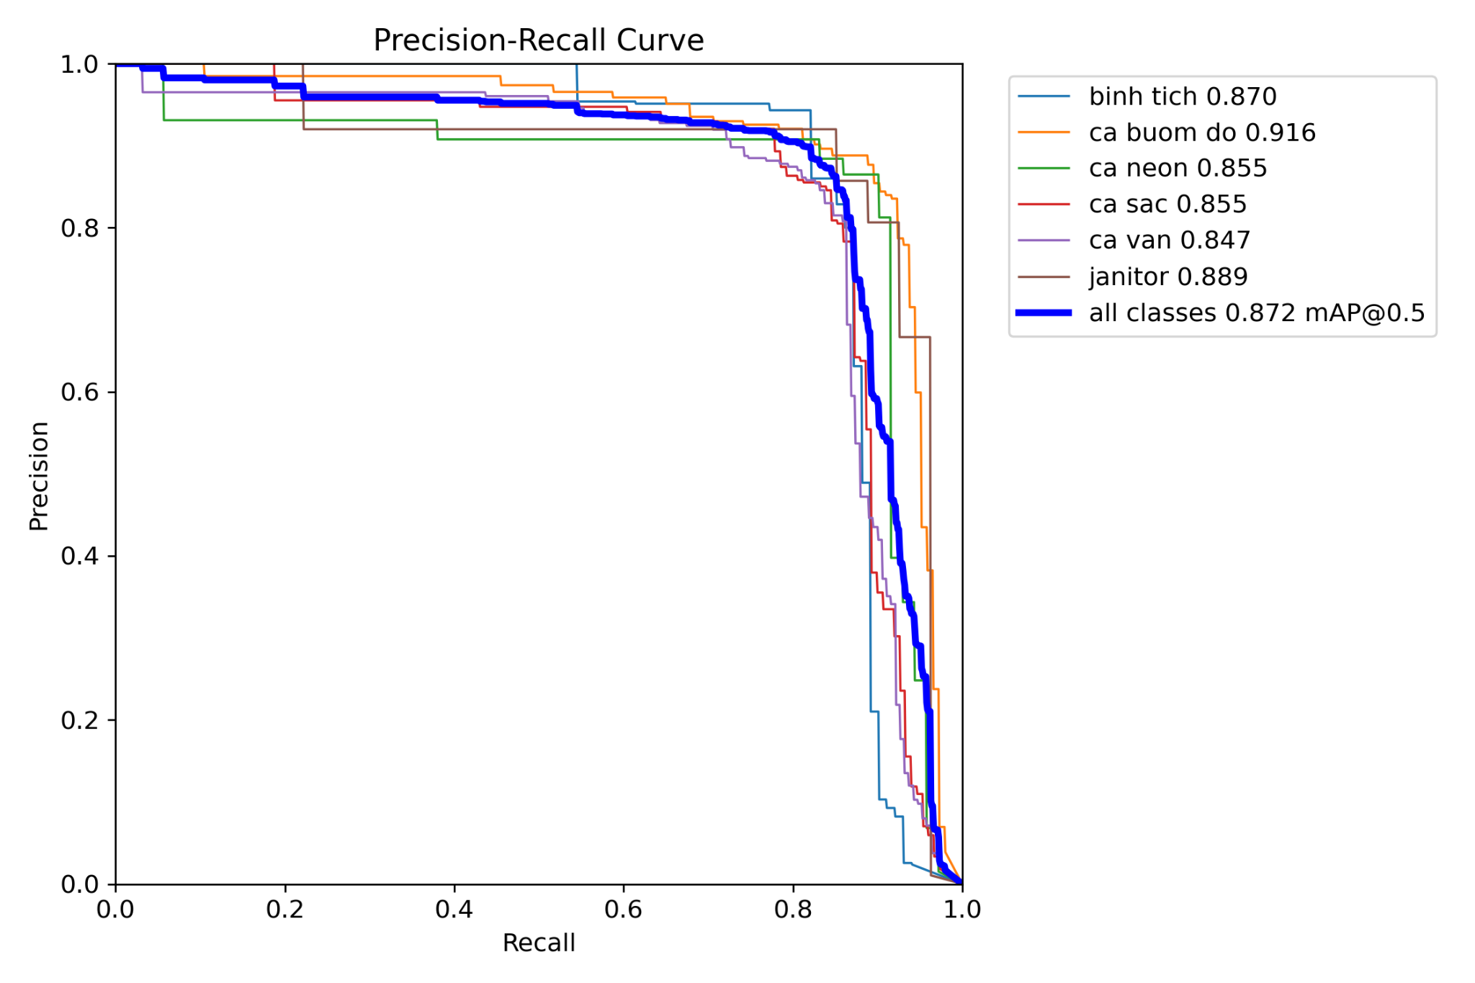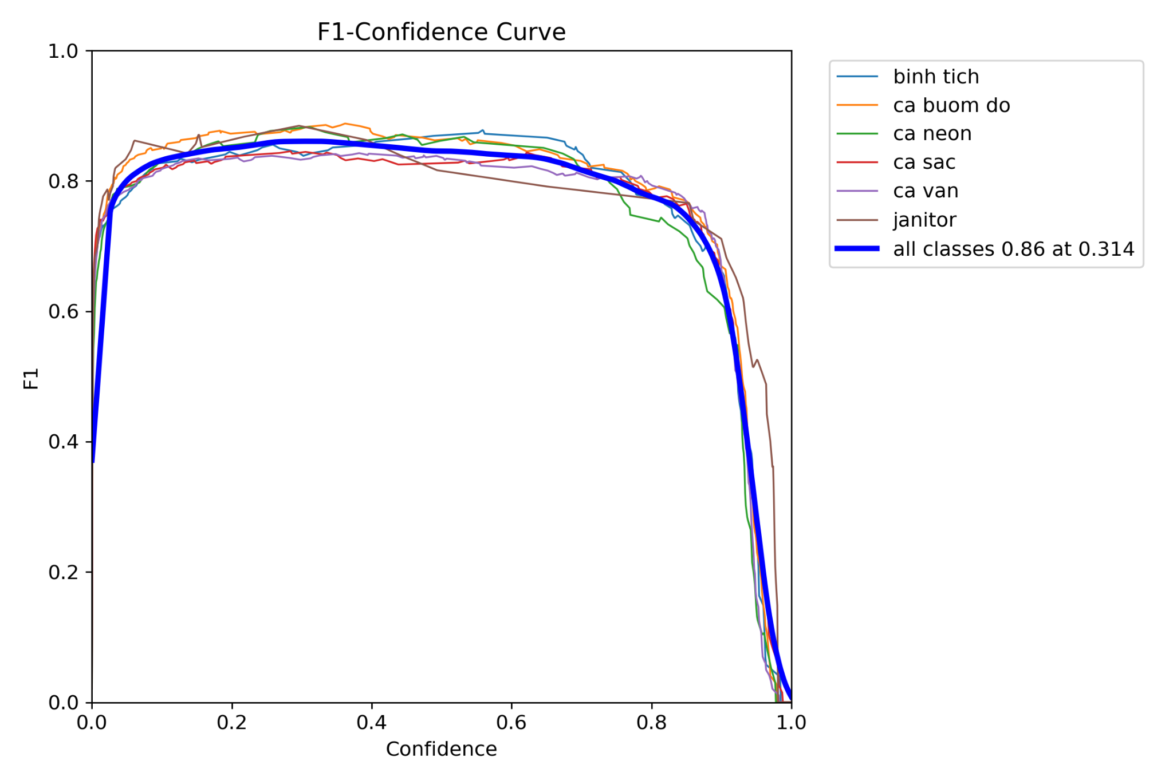

I also converted our model to tflite just like week 4. Surprisingly, this tflite model is not any less accurate than our current model using the same video. Plus, the computational and power requirement should be decreased so we can, hopefully, deploy it on edge devices. I also did the int8 quantization but the int8 model can’t detect any fish at all so I settled for float32 quantization. For the model size, for some weird reason our default model is 5.5 MB which is lighter than our float32 tflite model which is 9 MB. But it runs smoother than the default one.

**Week 9**

**Tra Dang Khoa:**

**Deployment: Successfully Interfacing and Deploying on OAK-D Camera**

In the deployment phase of our fish detection project, we successfully interfaced and deployed our YOLOv10 model on the OAK-D camera, which is known for its robust AI and depth-sensing capabilities.

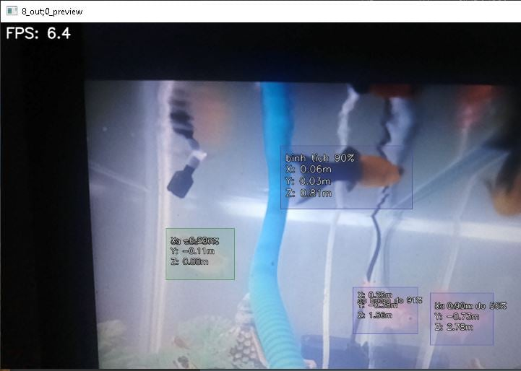

**Pre-Deployment Preparation:**

Before interfacing with the OAK-D camera, it was essential to convert our YOLOv10 model from its original PyTorch (.pt) format to a format compatible with the DepthAI library. This involved:

**Model Conversion**: We converted the .pt file to a .blob format, which is optimized for inference on the Myriad X VPU inside the OAK-D. The .blob file contains the model's weights and architecture compiled for the hardware.

**Configuration Files**: We also generated configuration files:.json: Contains additional parameters and metadata necessary for the model's operation on the OAK-D, such as class labels and input shapes. .bin: Although less common for this specific deployment, it can store additional model weights if required by the pipeline.

**Deployment Process:**

**Library and Code Utilization**: We leveraged the DepthAI library and example code provided by Luxonis, the creators of the OAK-D camera. Specifically, we adapted the scripts from their GitHub repository under the gen2-yolo/device-decoding directory. This code facilitates setting up a pipeline for neural network inference on the device, which includes:

* Setting up the camera nodes for input.
* Configuring the neural network node to run the .blob file.
* Managing data flow between the device and host for processing and visualization.

here is the code from the company: <https://github.com/luxonis/depthai-experiments/tree/master/gen2-yolo/device-decoding>

here is our project folder: <https://drive.google.com/drive/folders/1oXp-CTADRWqCJObEe6L-Xm7JdO_ZfWPE?usp=sharing>

**Nguyen Huu Minh Quang**

We intend to show a real case display with our model, my final task is to set up the sample for the model to be presented in the final presentation

**Preparation for Final Presentation**

**Fish species** : I have prepared many kinds of aquarium fishes. The selection showcases the model capability to detect and identify a wide range of aquatic life

**Aquarium environment setup** : Created an engaging and realistic aquarium environment for the display

**Display coordination** : Arranged the aquarium and fish to highlight the model’s performance across various conditions, make sure visibility and educational value for the audience

**Week 9 report conclusion :**

* Successfully deploying on oak-d camera, however, we still waiting for the car detection group to lend us the raspberry 5 as they still working on it
* Step-by-step moving toward the complete real-case display for the final presentation